PROJECT

# [7 Segment Display Interfacing with Arduino](https://circuitdigest.com/microcontroller-projects/7-segment-display-interfacing-with-arduino)

A seven segment display got its name from the very fact that it got seven illuminating segments. Each of these segments has a LED (Light Emitting Diode), hence the lighting. The LEDs are so fabricated that lighting of each LED is contained to its own segment. The important thing to notice here that the LEDs in any seven segment display are arranged in common anode mode (common positive) or common cathode mode (common negative).

Circuit and Working

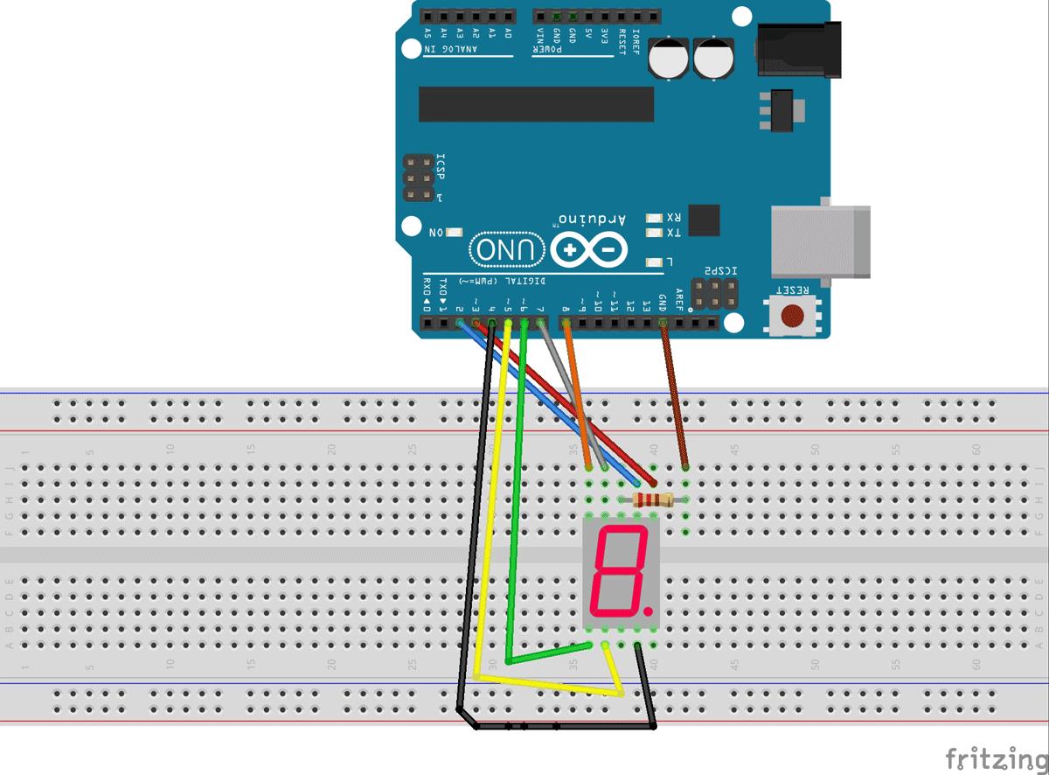

PIN CONNECTIONS

PIN1 or E to PIN 6 of ARDUINO UNO

PIN2 or D to PIN 5

PIN4 or C to PIN 4

PIN5 or H or DP to PIN 9 ///not needed as we are not using decimal point

PIN6 or B to PIN 3

PIN7 or A to PIN 2

PIN9 or F to PIN 7

PIN10 or G to PIN 8

PIN3 or PIN8 or CC to ground through 100Ω resistor.

WORKING

Now to understand the working, consider a seven segment display is connected to a port, so say we have connected “A segment of display to PIN0”, “B segment of display to PIN1”, “A segment of display to PIN3”, “A segment of display to PIN4”, “A segment of display to PIN5”, “A segment of display to PIN6”. And is common ground type as shown in figure.

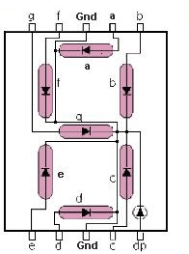

Here the common ground has to be connected to ground for the display to work. One can check each segment of display by using multimeter in diode mode. Each segment should not be power with a voltage greater than 4v, if did the display will be damaged permanently. For avoiding this a common resistor can be provider at common terminal, as shown in circuit diagram.

Now, if we want to display a “0” in this display as shown in below figure.

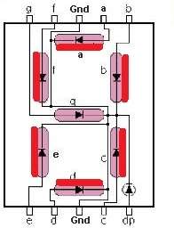

We need to turn the LEDs of segments “A, B, C, D, E F”, so we need to power PIN0, PIN1, PIN2, PIN3, PIN4 and PIN5. So every time we need a “0”, we need to power all the pins mentioned.

Now, if we want “1” on display

CODE

#define segA 2//connecting segment A to PIN2

#define segB 3// connecting segment B to PIN3

#define segC 4// connecting segment C to PIN4

#define segD 5// connecting segment D to PIN5

#define segE 6// connecting segment E to PIN6

#define segF 7// connecting segment F to PIN7

#define segG 8// connecting segment G to PIN8

int COUNT=0;//count integer for 0-9 increment

void setup()

{

for (int i=2;i<9;i++)

{

pinMode(i, OUTPUT);// taking all pins from 2-8 as output

}

}

void loop()

{

switch (COUNT)

{

case 0://when count value is zero show”0” on disp

digitalWrite(segA, HIGH);

digitalWrite(segB, HIGH);

digitalWrite(segC, HIGH);

digitalWrite(segD, HIGH);

digitalWrite(segE, HIGH);

digitalWrite(segF, HIGH);

digitalWrite(segG, LOW);

break;

case 1:// when count value is 1 show”1” on disp

digitalWrite(segA, LOW);

digitalWrite(segB, HIGH);

digitalWrite(segC, HIGH);

digitalWrite(segD, LOW);

digitalWrite(segE, LOW);

digitalWrite(segF, LOW);

digitalWrite(segG, LOW);

break;

case 2:// when count value is 2 show”2” on disp

digitalWrite(segA, HIGH);

digitalWrite(segB, HIGH);

digitalWrite(segC, LOW);

digitalWrite(segD, HIGH);

digitalWrite(segE, HIGH);

digitalWrite(segF, LOW);

digitalWrite(segG, HIGH);

break;

case 3:// when count value is 3 show”3” on disp

digitalWrite(segA, HIGH);

digitalWrite(segB, HIGH);

digitalWrite(segC, HIGH);

digitalWrite(segD, HIGH);

digitalWrite(segE, LOW);

digitalWrite(segF, LOW);

digitalWrite(segG, HIGH);

break;

case 4:// when count value is 4 show”4” on disp

digitalWrite(segA, LOW);

digitalWrite(segB, HIGH);

digitalWrite(segC, HIGH);

digitalWrite(segD, LOW);

digitalWrite(segE, LOW);

digitalWrite(segF, HIGH);

digitalWrite(segG, HIGH);

break;

case 5:// when count value is 5 show”5” on disp

digitalWrite(segA, HIGH);

digitalWrite(segB, LOW);

digitalWrite(segC, HIGH);

digitalWrite(segD, HIGH);

digitalWrite(segE, LOW);

digitalWrite(segF, HIGH);

digitalWrite(segG, HIGH);

break;

case 6:// when count value is 6 show”6” on disp

digitalWrite(segA, HIGH);

digitalWrite(segB, LOW);

digitalWrite(segC, HIGH);

digitalWrite(segD, HIGH);

digitalWrite(segE, HIGH);

digitalWrite(segF, HIGH);

digitalWrite(segG, HIGH);

break;

case 7:// when count value is 7 show”7” on disp

digitalWrite(segA, HIGH);

digitalWrite(segB, HIGH);

digitalWrite(segC, HIGH);

digitalWrite(segD, LOW);

digitalWrite(segE, LOW);

digitalWrite(segF, LOW);

digitalWrite(segG, LOW);

break;

case 8:// when count value is 8 show”8” on disp

digitalWrite(segA, HIGH);

digitalWrite(segB, HIGH);

digitalWrite(segC, HIGH);

digitalWrite(segD, HIGH);

digitalWrite(segE, HIGH);

digitalWrite(segF, HIGH);

digitalWrite(segG, HIGH);

break;

case 9:// when count value is 9 show”9” on disp

digitalWrite(segA, HIGH);

digitalWrite(segB, HIGH);

digitalWrite(segC, HIGH);

digitalWrite(segD, HIGH);

digitalWrite(segE, LOW);

digitalWrite(segF, HIGH);

digitalWrite(segG, HIGH);

break;

break;

}

if (COUNT<10)

{

COUNT++;

delay(1000);///increment count integer for every second

}

if (COUNT==10)

{

COUNT=0;// if count integer value is equal to 10, reset it to zero.

delay(1000);

}

}

